EXPERIMENT NO. 11
UML DIAGRAMS FOR A COLLEGE SECURITY MANAGEMENT SYSTEM

AIM
To design the Class diagram, Use Case diagram and Activity diagram for an Online Food Delivery System showing the relevant classes, attributes, methods, actors and workflow.
SOFTWARE / TOOLS REQUIRED
- Umbrello UML Modeller / StarUML
- Windows / Linux PC
PROCEDURE
Step 1: Launch the UML Modeling Tool
- Open StarUML or any UML modeling software.
- Create a new project.
- Save the project with the name "Online Food Delivery System."
Step 2: Analyze the Problem Statement
- Read the given problem carefully.
- Identify the main functionalities of the system.
- List the actors, classes, and activities required for the system.
- Plan the diagrams before creating them.
Step 3: Create the Class Diagram
- Add a new Class Diagram to the project.
- Create the required classes such as Customer, Restaurant, Menu, Food Item, Order, Payment, Delivery Agent, and Delivery.
- Add suitable attributes for each class.
- Add appropriate methods for each class.
- Connect the classes using suitable relationships such as association, aggregation, composition, and inheritance.
- Verify that the relationships correctly represent the system.
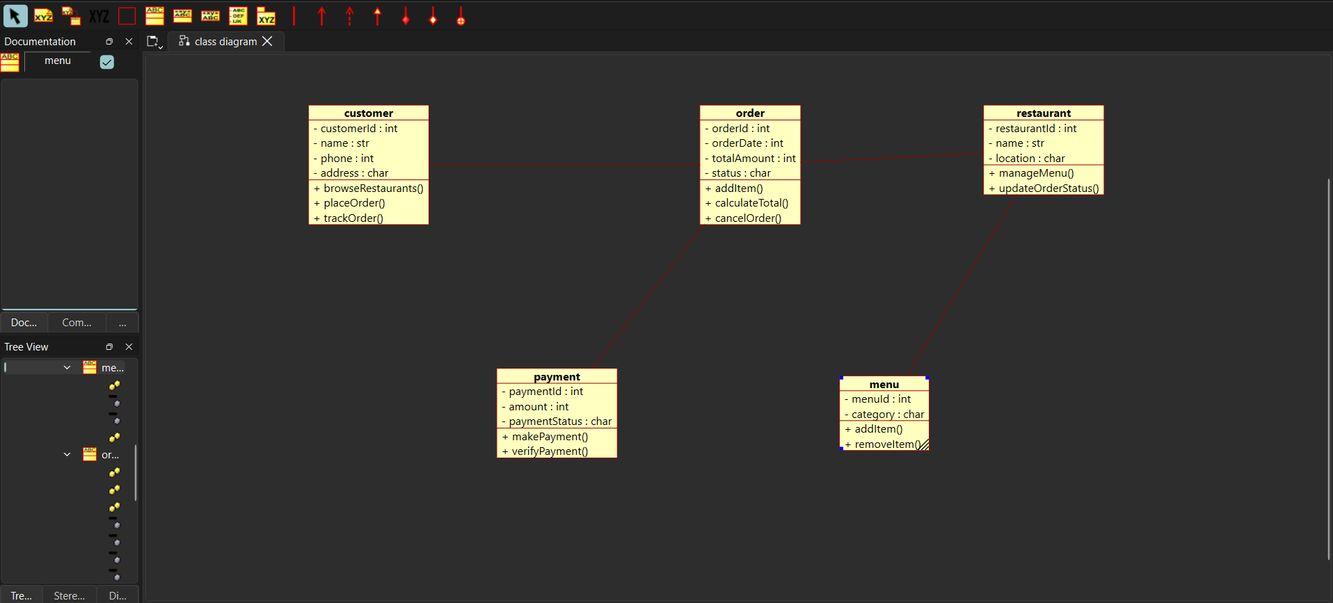
Step 4: Create the Use Case Diagram
- Add a new Use Case Diagram.
- Create the actors such as Customer, Restaurant, Delivery Agent, and Administrator.
- Add the use cases including Browse Restaurants, View Menu, Place Order, Make Payment, Track Order, Manage Menu, Update Order Status, Accept Delivery Request, and Update Delivery Status.
- Connect each actor with the corresponding use cases using association relationships.
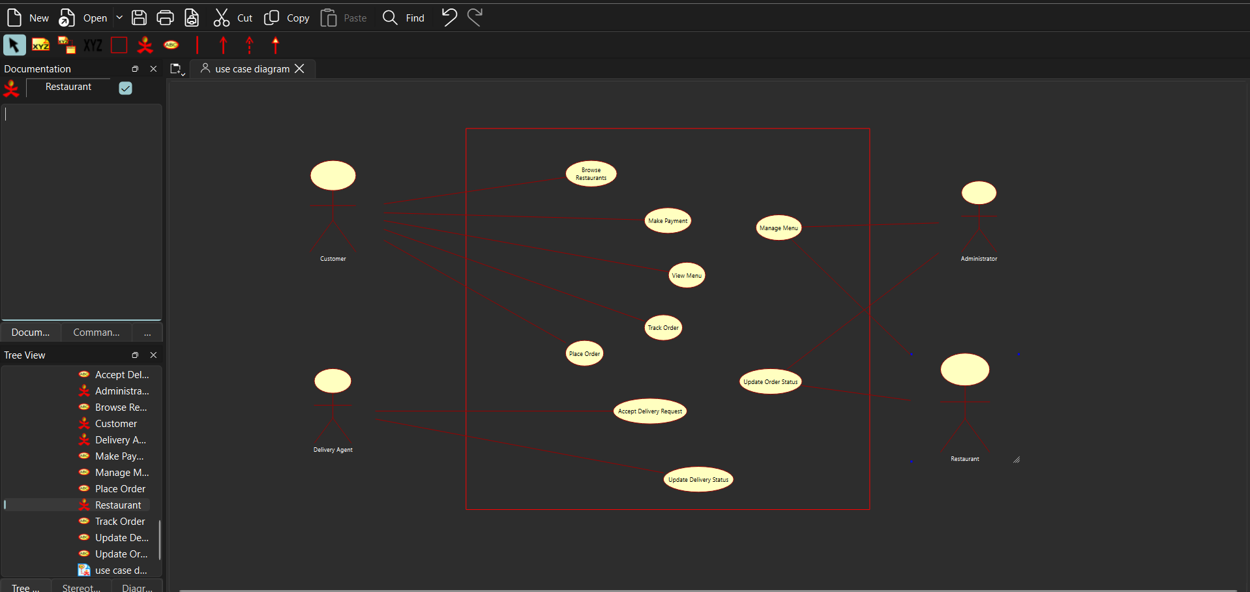
Step 5: Create the Activity Diagram
- Add a new Activity Diagram.
- Insert the Initial Node to represent the start of the process.
- Create the activities in sequence, including browsing restaurants, selecting food items, placing an order, making payment, restaurant confirmation, assigning a delivery agent, tracking delivery, and completing the order.
- Use decision nodes wherever conditions are required.
- Connect all activities using control flow arrows.
- End the process using the Final Node.
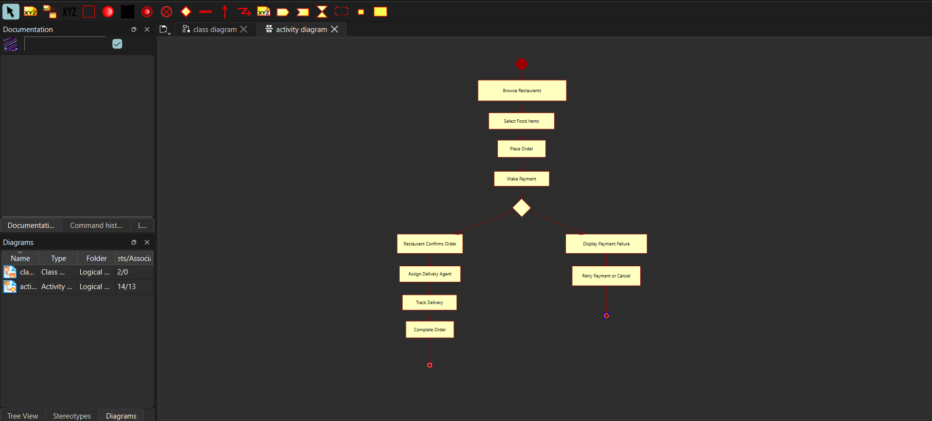
Step 6: Verify the Class Diagram
- Check whether all classes contain the required attributes and methods.
- Ensure that all relationships are connected correctly.
- Verify that the diagram satisfies the given requirements.
Step 7: Verify the Use Case Diagram
- Ensure that all actors are connected to the appropriate use cases.
- Verify that all system functionalities are included.
- Check the correctness of the associations.
Step 8: Verify the Activity Diagram
- Review the sequence of activities.
- Check the decision points and control flow.
- Ensure that the workflow represents the food delivery process correctly.
Step 9: Save the UML Project
- Save all the diagrams in the project.
- Store the project with an appropriate file name.
Step 10: Export the Diagrams
- Export the Class Diagram, Use Case Diagram, and Activity Diagram as image or PDF files.
- Verify that all diagrams are complete and ready for submission.
EXPECTED OUTPUT
- Class diagram with classes Customer, Restaurant, Menu, FoodItem, Order, Payment, DeliveryAgent, Delivery and their relationships.
- Use Case diagram with actors Customer, Restaurant, Delivery Agent, Administrator and use cases such as Browse Restaurants, Place Order, Make Payment, Track Order, Manage Menu, Accept Delivery.
- Activity diagram from browsing restaurants to order completion with decision nodes for payment success.
RESULT
Thus the Class, Use Case and Activity diagrams for the Online Food Delivery System were designed using the UML tool and verified successfully.

